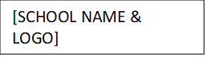
Threat Assessment Intervention Plan
Follow-up Meeting Summary

Date:
Team Members Present:

PROGRESS REVIEW
Intervention | Person Responsible | Progress* | Comments
*1 – No Change; 2 – Minimal Progress; 3 – Some Progress; 4 – Significant Progress; 5 – Intervention no longer needed

Any further interventions needed:

Other comments from team members:

